**SED Challenge**

**Infrastructure**

For this project, please think about how you would architect a scalable and secure static web application in AWS.

* Create and deploy a running instance of a web server using a configuration management tool of your choice. The web server should serve one page with the following content.

<html>

<head>

<title>Hello World</title>

</head>

<body>

<h1>Hello World!</h1>

</body>

</html>

* Secure this application and host such that only appropriate ports are publicly exposed and any http requests are redirected to https. This should be automated using a configuration management tool of your choice and you should feel free to use a self-signed certificate for the web server.
* Develop and apply automated tests to validate the correctness of the server configuration.
* Express everything in code.
* Provide your code in a Git repository named <FIRSTNAME>_Challenge on GitHub.com

Be prepared to walk though your code, discuss your thought process, and talk through how you might monitor and scale this application. You should also be able to demo a running instance of the host.

**Challenge – 1**

**Solution:**

**I can add my way of approach to this project in below steps.**

* Now to a build a scalable web application in AWS cloud there are certain steps and best practices to be followed to build the scalable web application and deploy in the web server.
* Now let’s look into each step in detail and I would be adding the screenshot of each step and I would be defining them in a appropriate manner.

**Step - 1**

**Setting up the Environment**

* For this project we can use AWS services like Amazon EC2, Amazon S3, and AWS CloudFront to host a scalable and secure static website.

Now to take a deep dive of the range of services used for this project.

Step – 2

**Architecture Design**

In this step I had given an overview on how the project is designed and how I would be proceeding a head on next steps

* **EC2 Instance**
* **S3 Bucket**
* **CloudFront Distribution**.

Step – 3

**Creation and configuring the EC2 Instance**

* **Launch an EC2 Instance**:

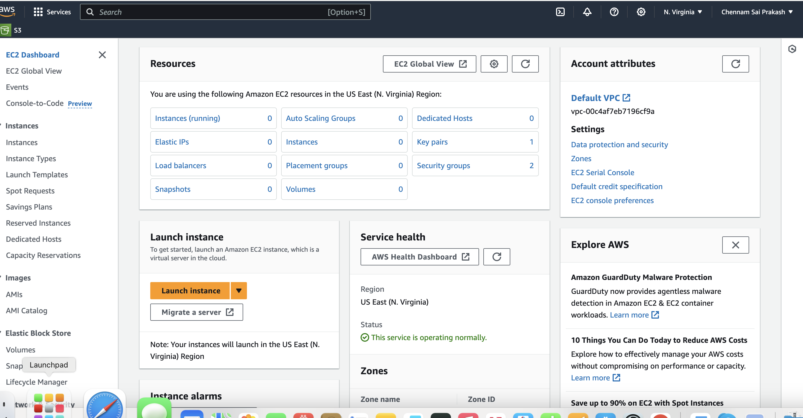

* Search for EC2 Instance on the AWS Management console Homepage and Launch the Instance by hitting the **Launch Instance** Button

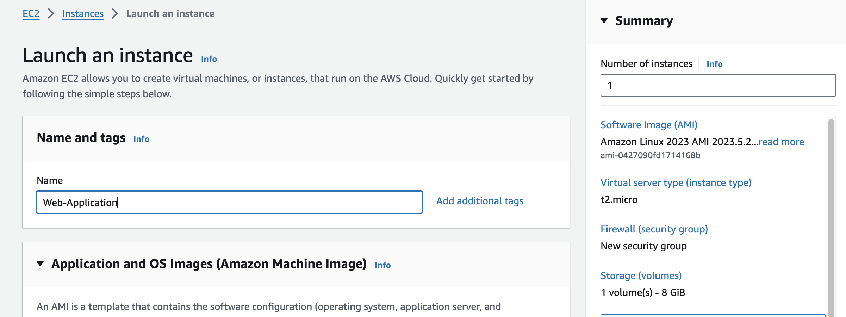

* After Launching the EC2 instance, I had Configured the Instance Name as **WebApplication** and I had chosen the Operating system as **Ubuntu (**Can also choose **Amazon Linux 2)** either of the one can be picked of choice.

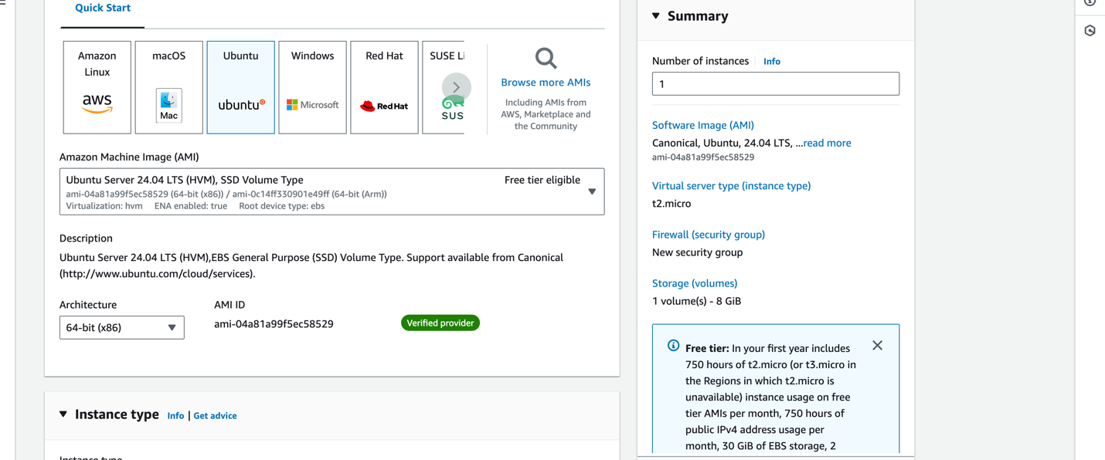

* And now after choosing the **Ubuntu OS** again AWS pops up asking the user to pick which version of Ubuntu needs to use for the Instance. I had chosen Free tier service for now as it is chargeable.
* A point to be noted here we can the free tier Instance upto 750 hours on one user account. We should categorize the selection of service based upon the memory size of application which we tend to deploy and AWS cloud charges according to it.
  + **Select an instance type (e.g., t2.micro).**

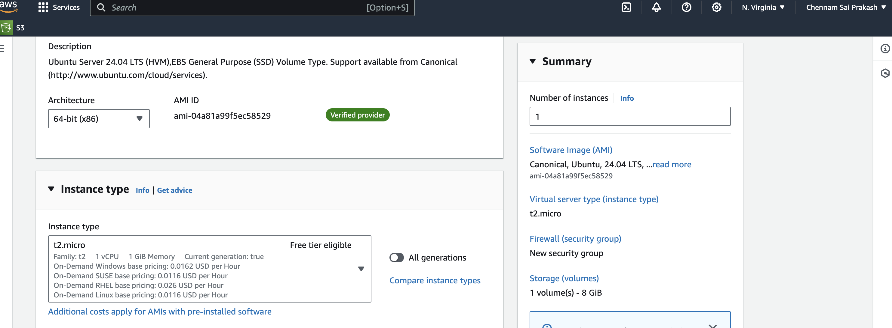

* **Key Value Pair/Key Pair**

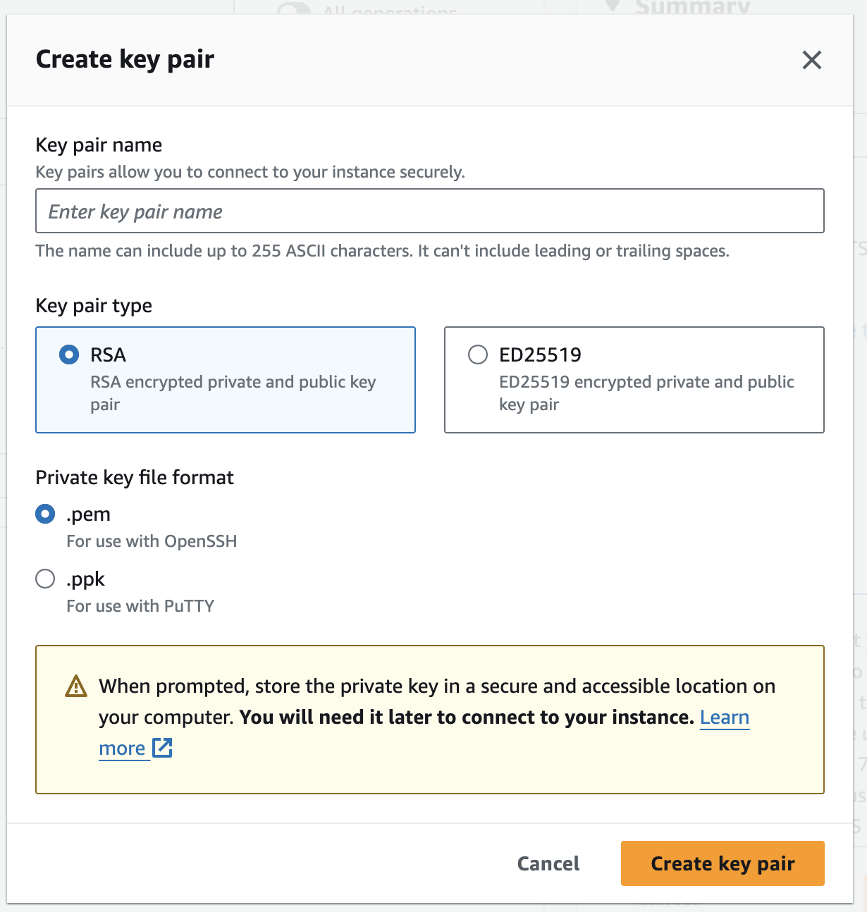

Key Pair is very important for an EC2 Instance. It is the actual once that helps to login into the Instance.

**Key Value Pair** is a combination of public/private key which is used to login to that instance.

By default, when a instance is created in the AWS it does not provide Password. The password authentication to the instance is disabled by default.

The only way to login to the instance is through AWS Key Value Pair.

We should ensure that this private **key pair should not** be shared to anyone.

* We can configure the key pair name by our choice and select the type as default. And click create the key pair.
* As I had one key pair already created with name **saitest** I am using the same key pair to login into the instance.
* **Configuring the Security Groups**

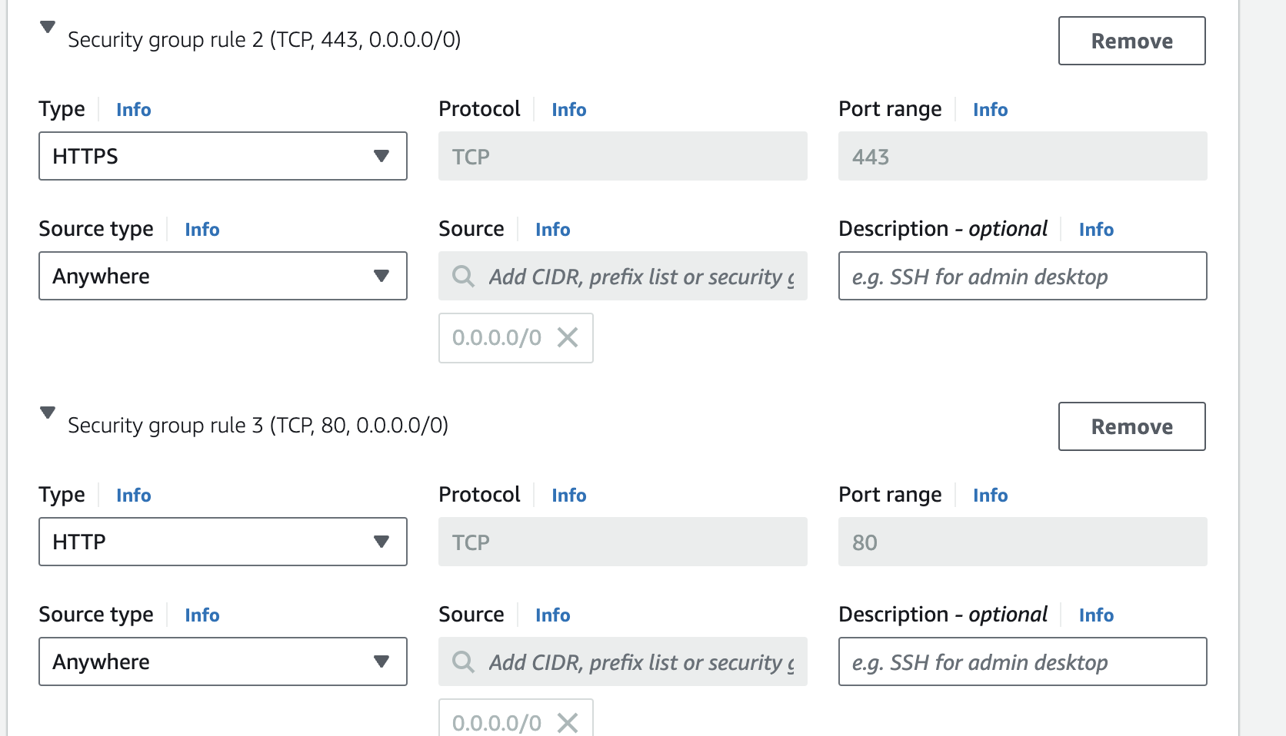

* As per the requirement I had configured the security groups to allow only **HTTP** (port 80) and **HTTPS** (port 443) traffic.
* Technically while configuring security groups we can ensure at how many availability zones it can accessed.

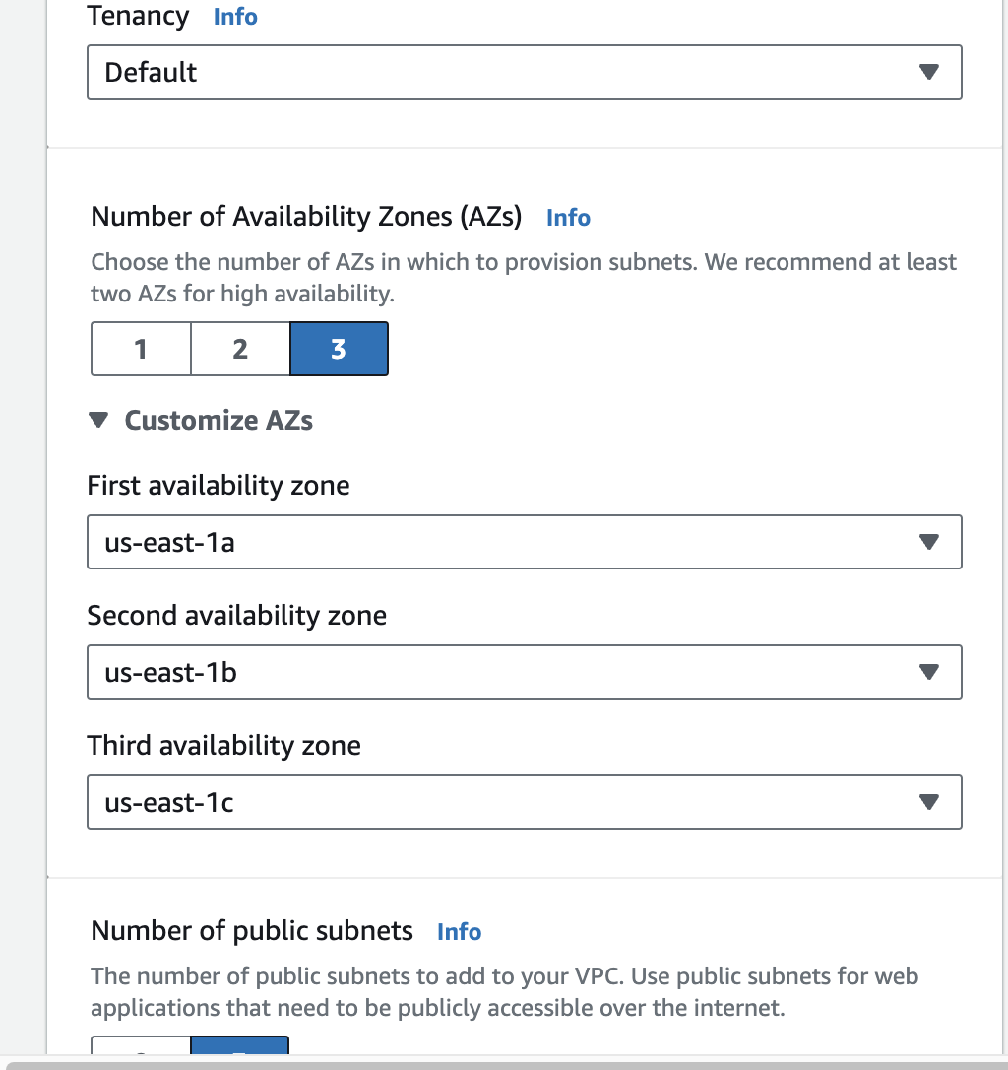

* After configuring I had created the VPC and configured it. Now the VPC configuration is done. I had configured it according to my requirement.
* Here is the beauty of AWS Cloud. It provides all the services at one Go. And security is the shared responsibility.
* AWS creates configurations while creating VPC, additionally we need to look into them and modify them according to our requirement.



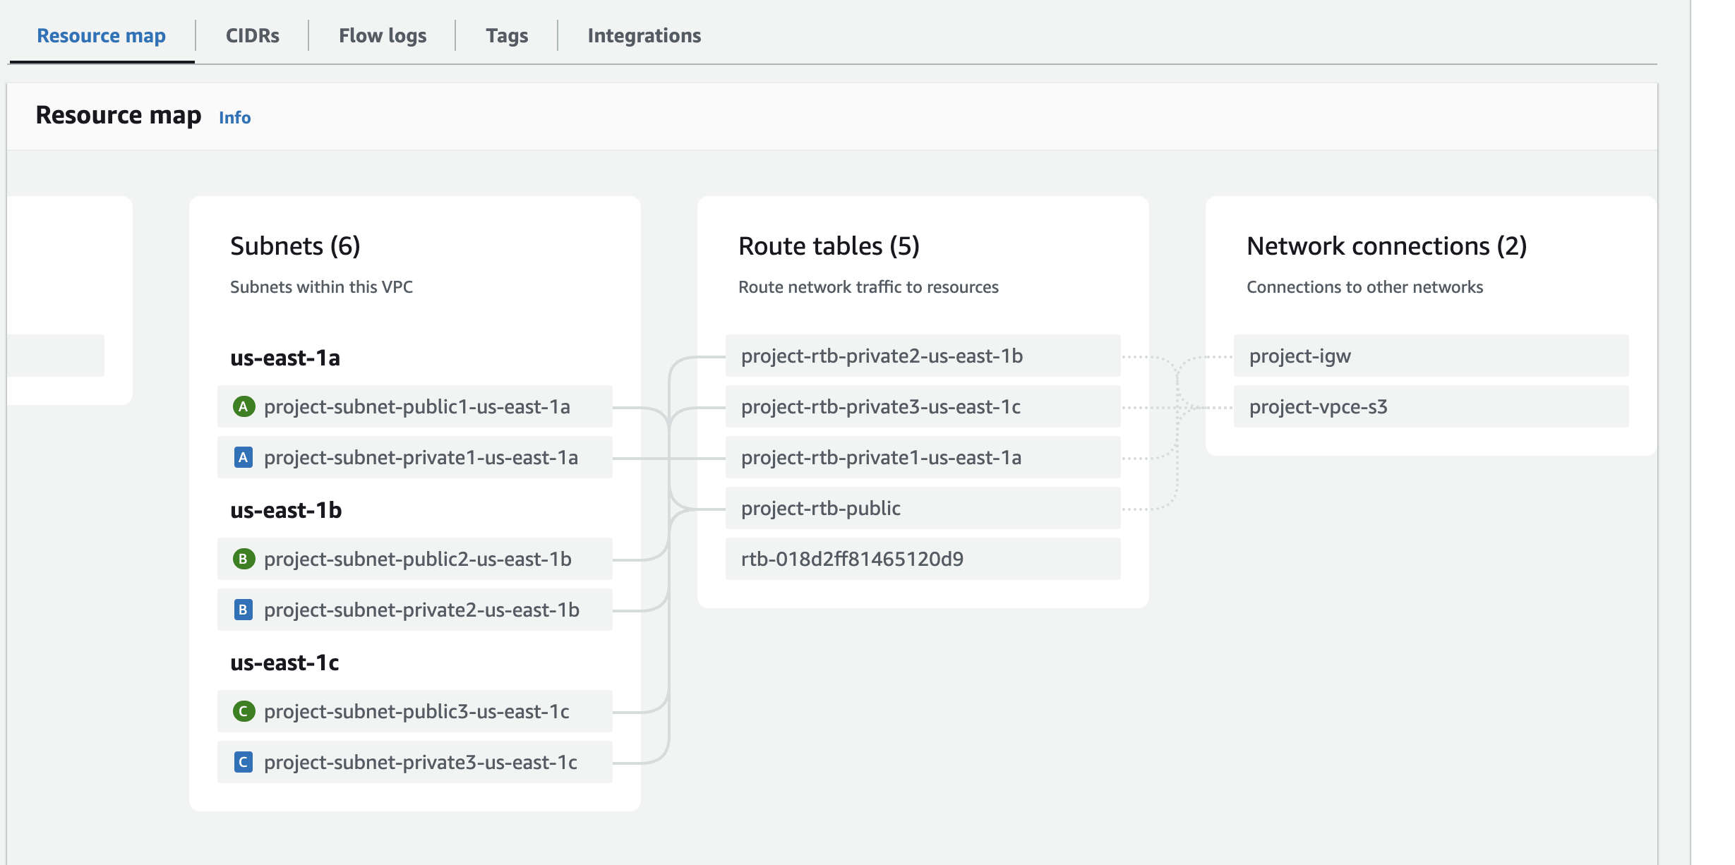

* This is the overview of our VPC and security of the instance created.

**Step – 4**

* As mentioned earlier for configuration Management I choose **Ansible.**  So I configured the Ansible in Ubuntu.

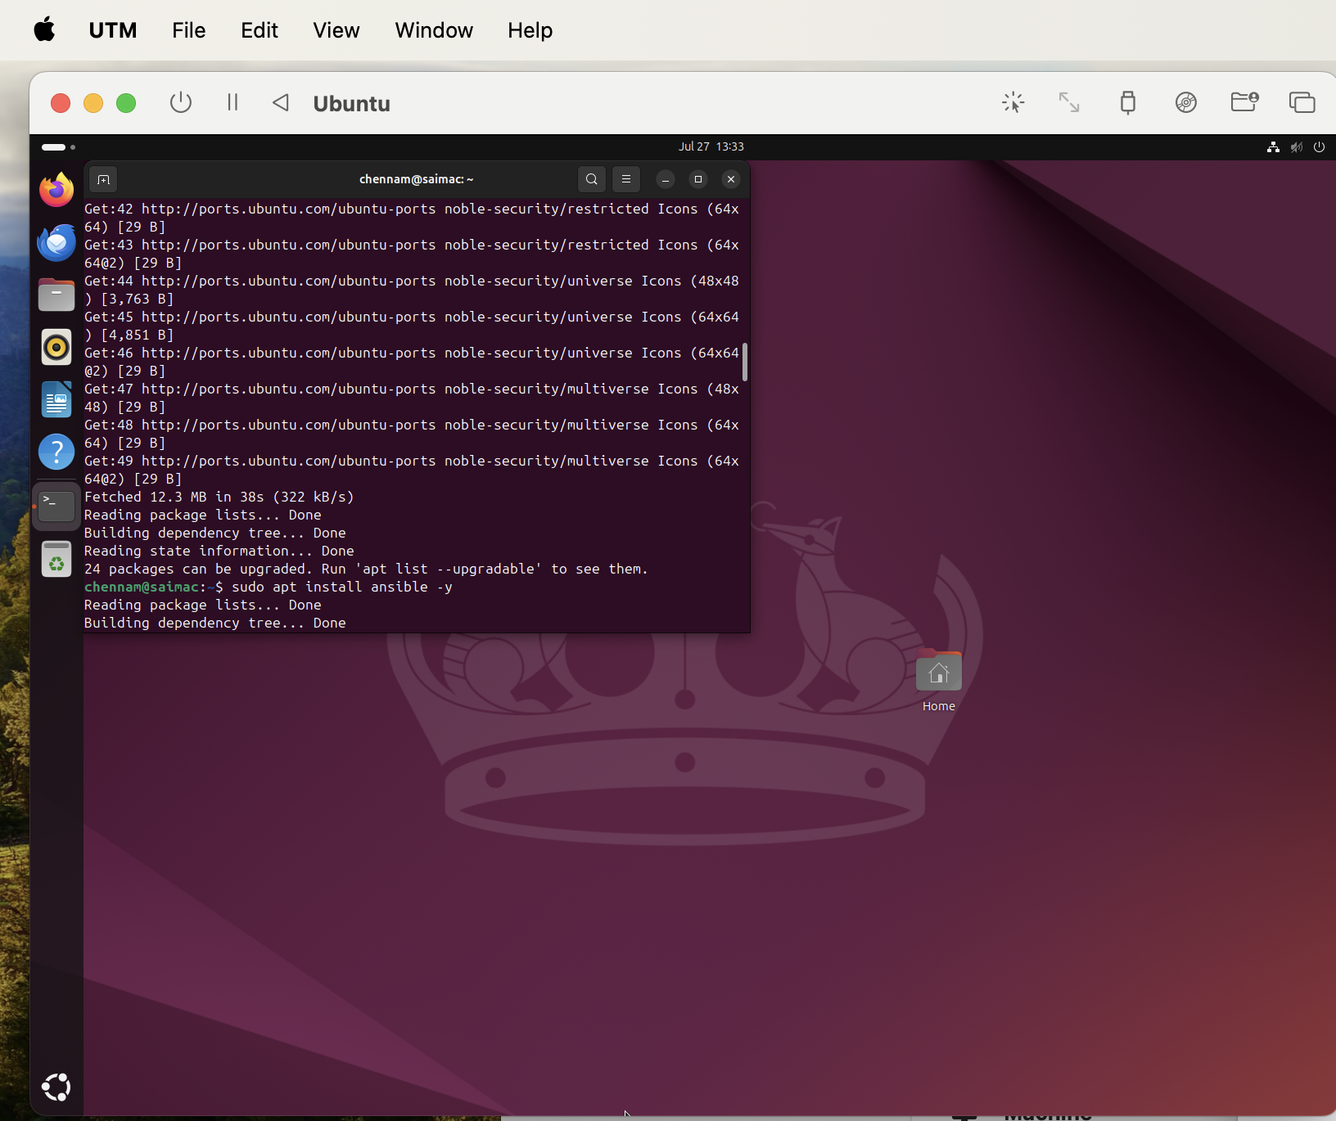

In the above I Installed the ansible and configured to the desired path



* The final state of the machine after Setting up the directory to the path and confirmation of the local machine after creation of folder in the local.

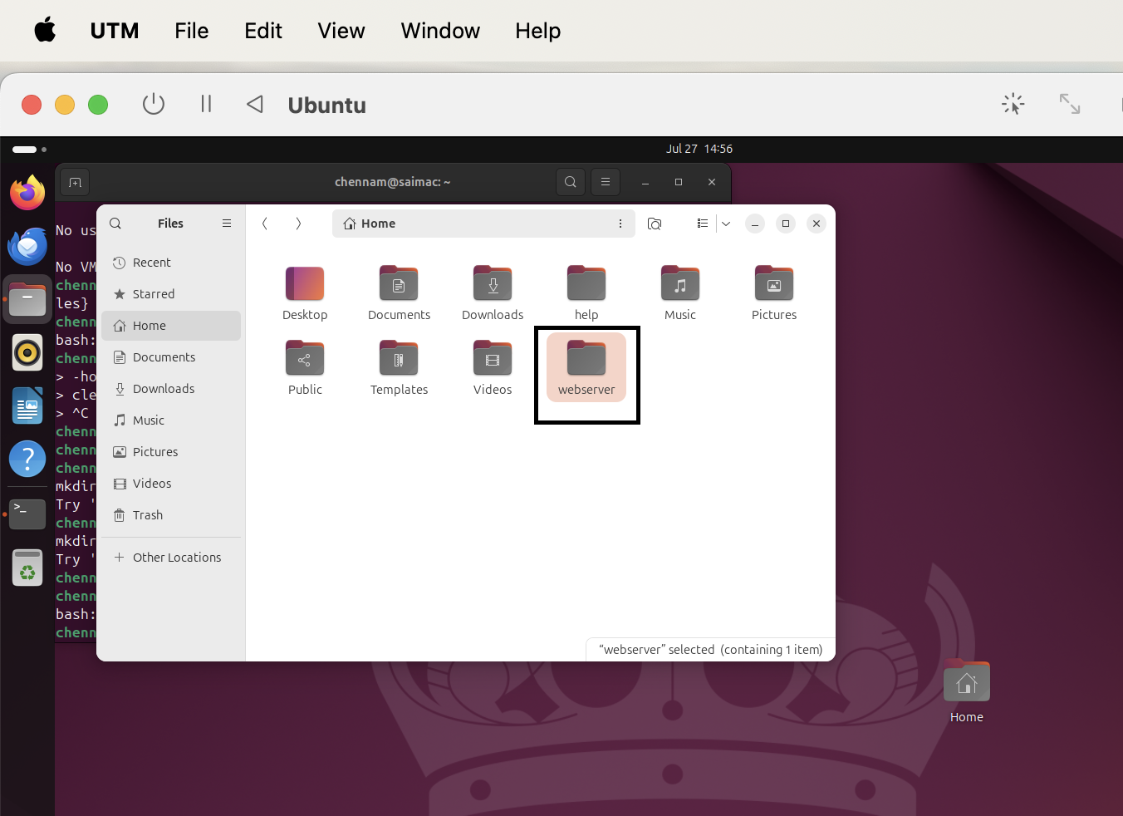

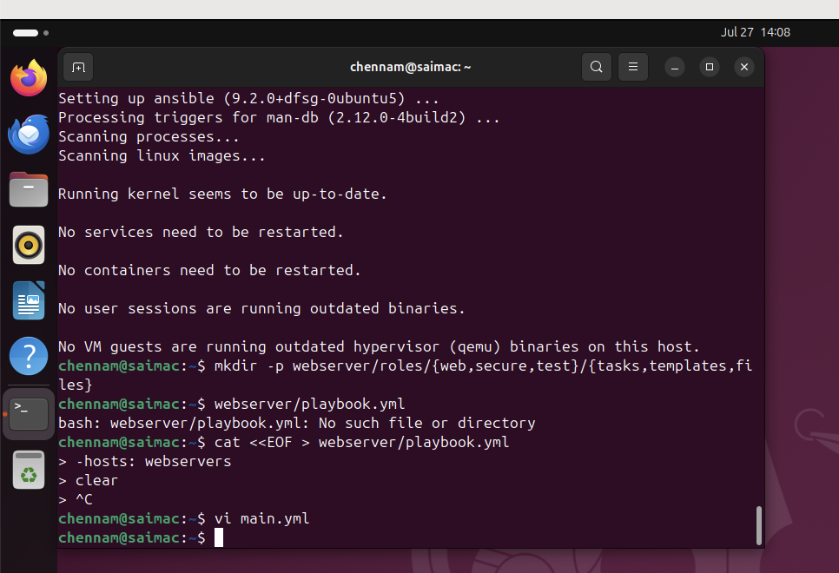

* First step after creation of directory is to configure the yml script files.

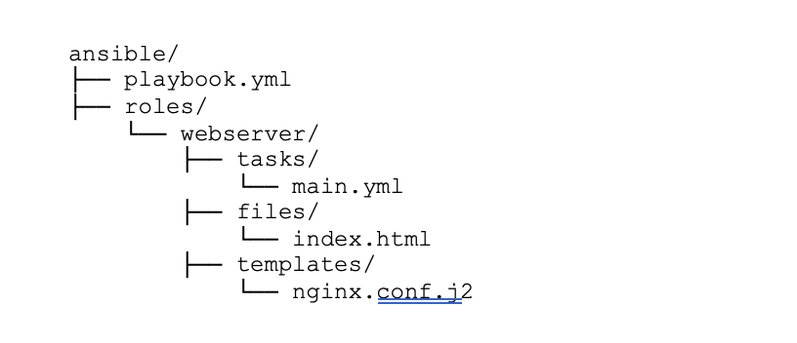

Configuration directory structure

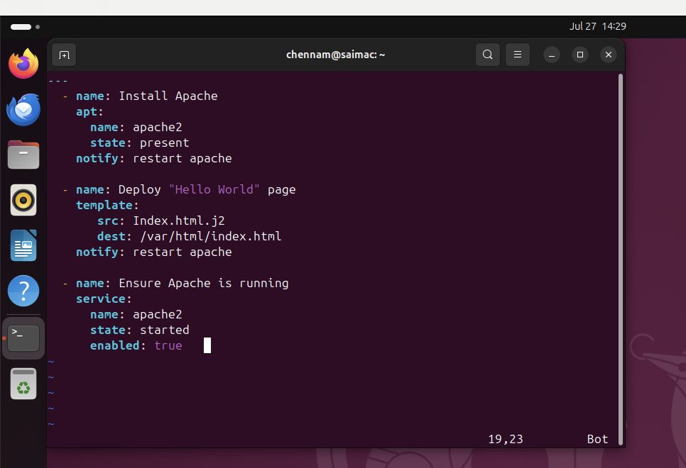

* Configuration script of Main. yml file

Point to noted:

**Commands**

* To edit the file give the command Vi filename.yml
* Once done with scripting to save the file in normal mode Press **Esc.**  And then Type **:wq** and press Enter.

Similarly Need to add the script for playbook.yml

Screenshots of the folders created the in the directory path.

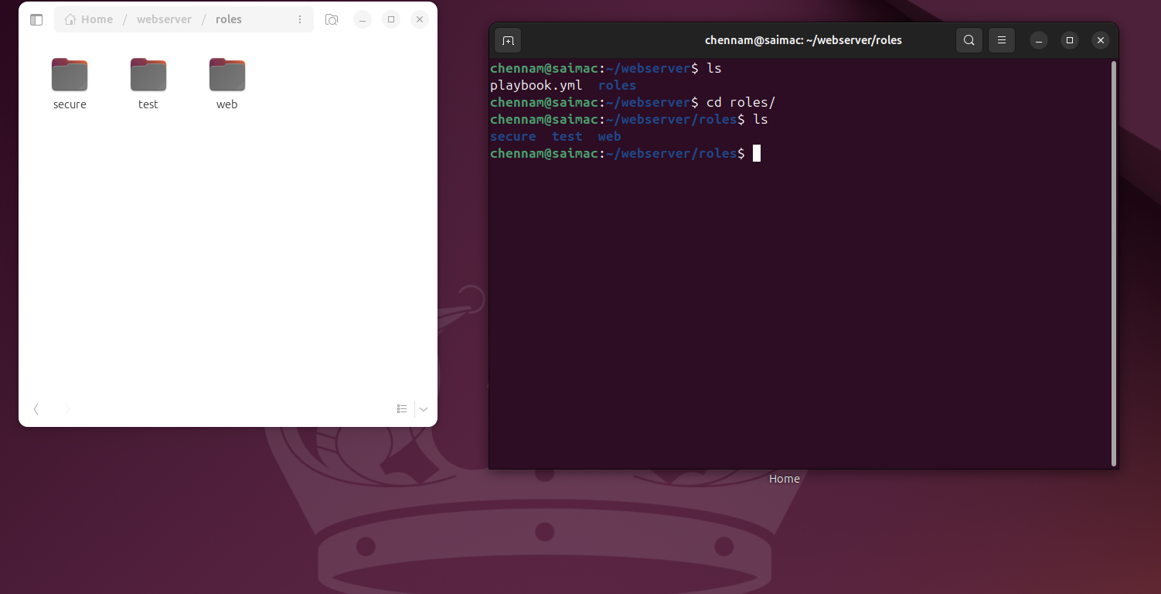

For the reference I would be adding all the script files and html files which were added in the Vm to Git Link for the reference.

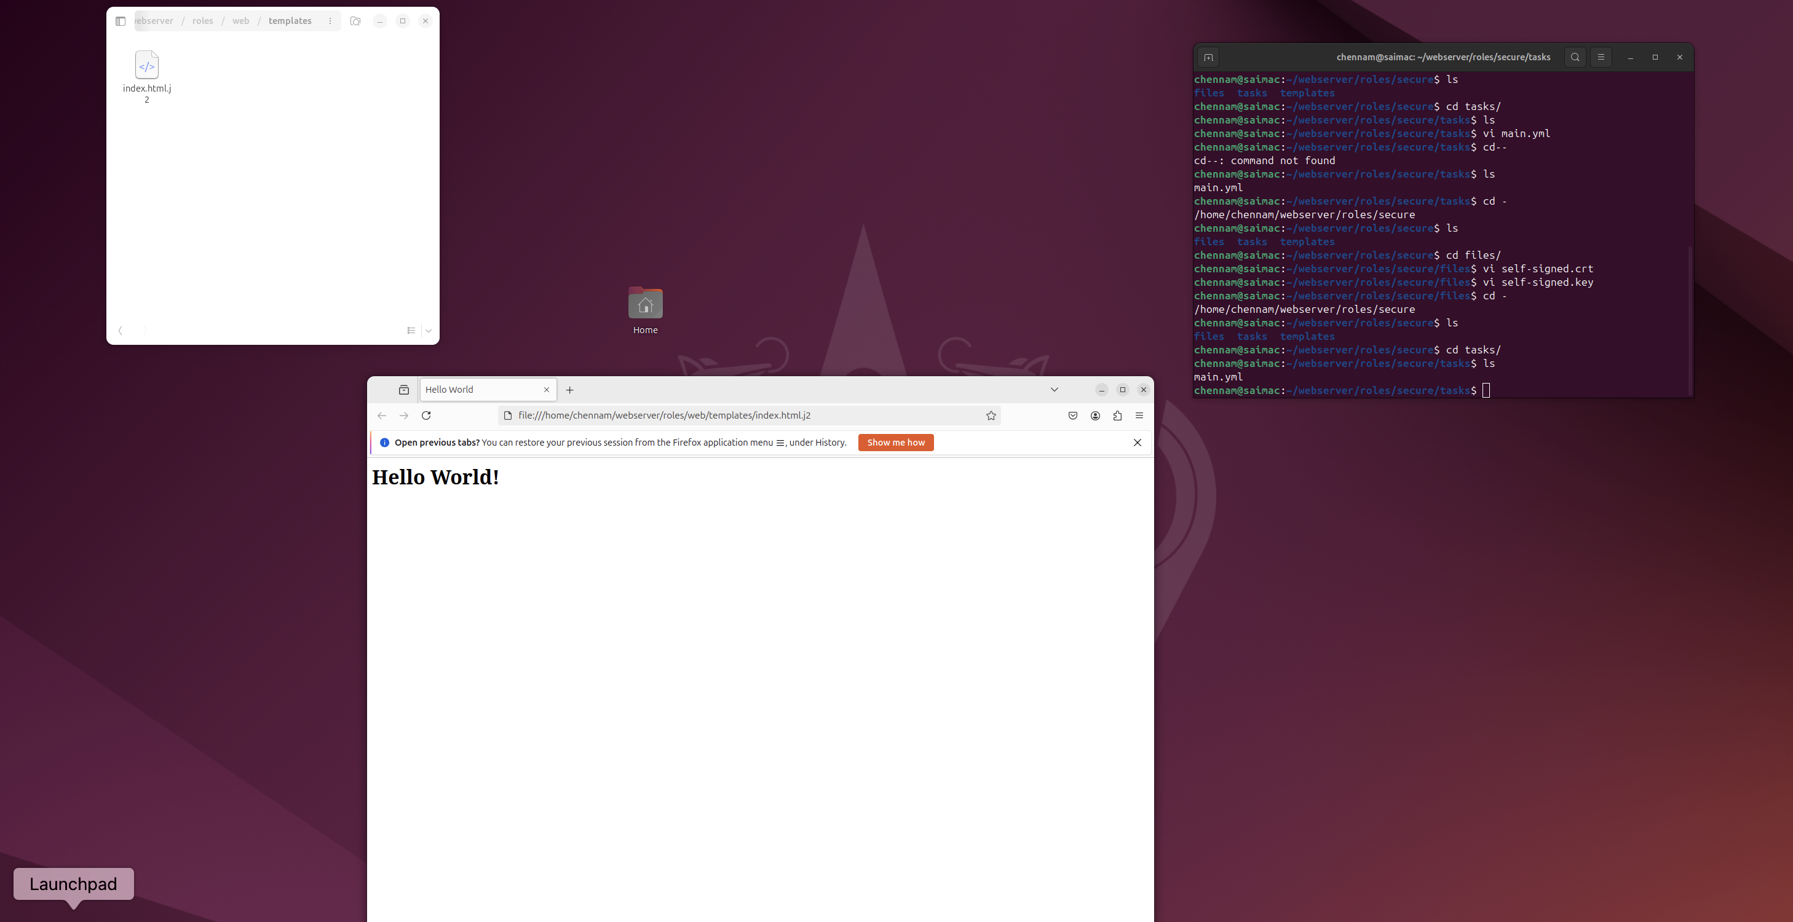

* This is the final output obtained on the web page in Ubuntu.

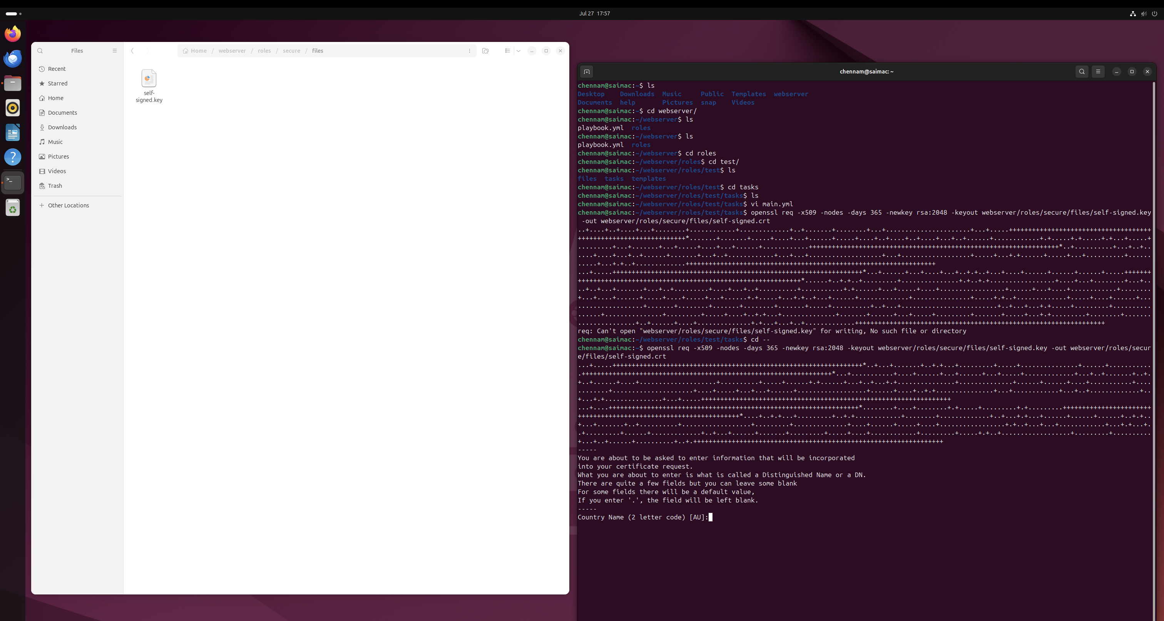

* SSL Security certificate is created

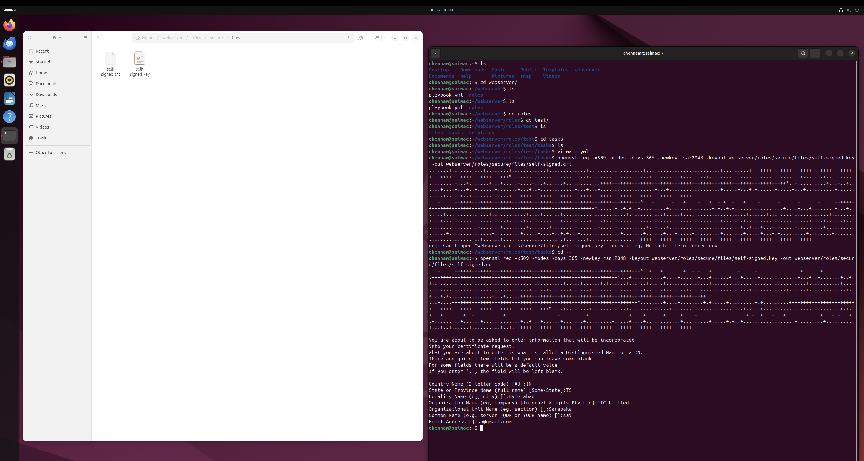

* SSL Certificate is created with the Key details added in it. And to its confirmation signed key is created with in due course of giving the entries.
* With this the Step – 4 Configuration of the Web application and creation on SSL security to the application is done.

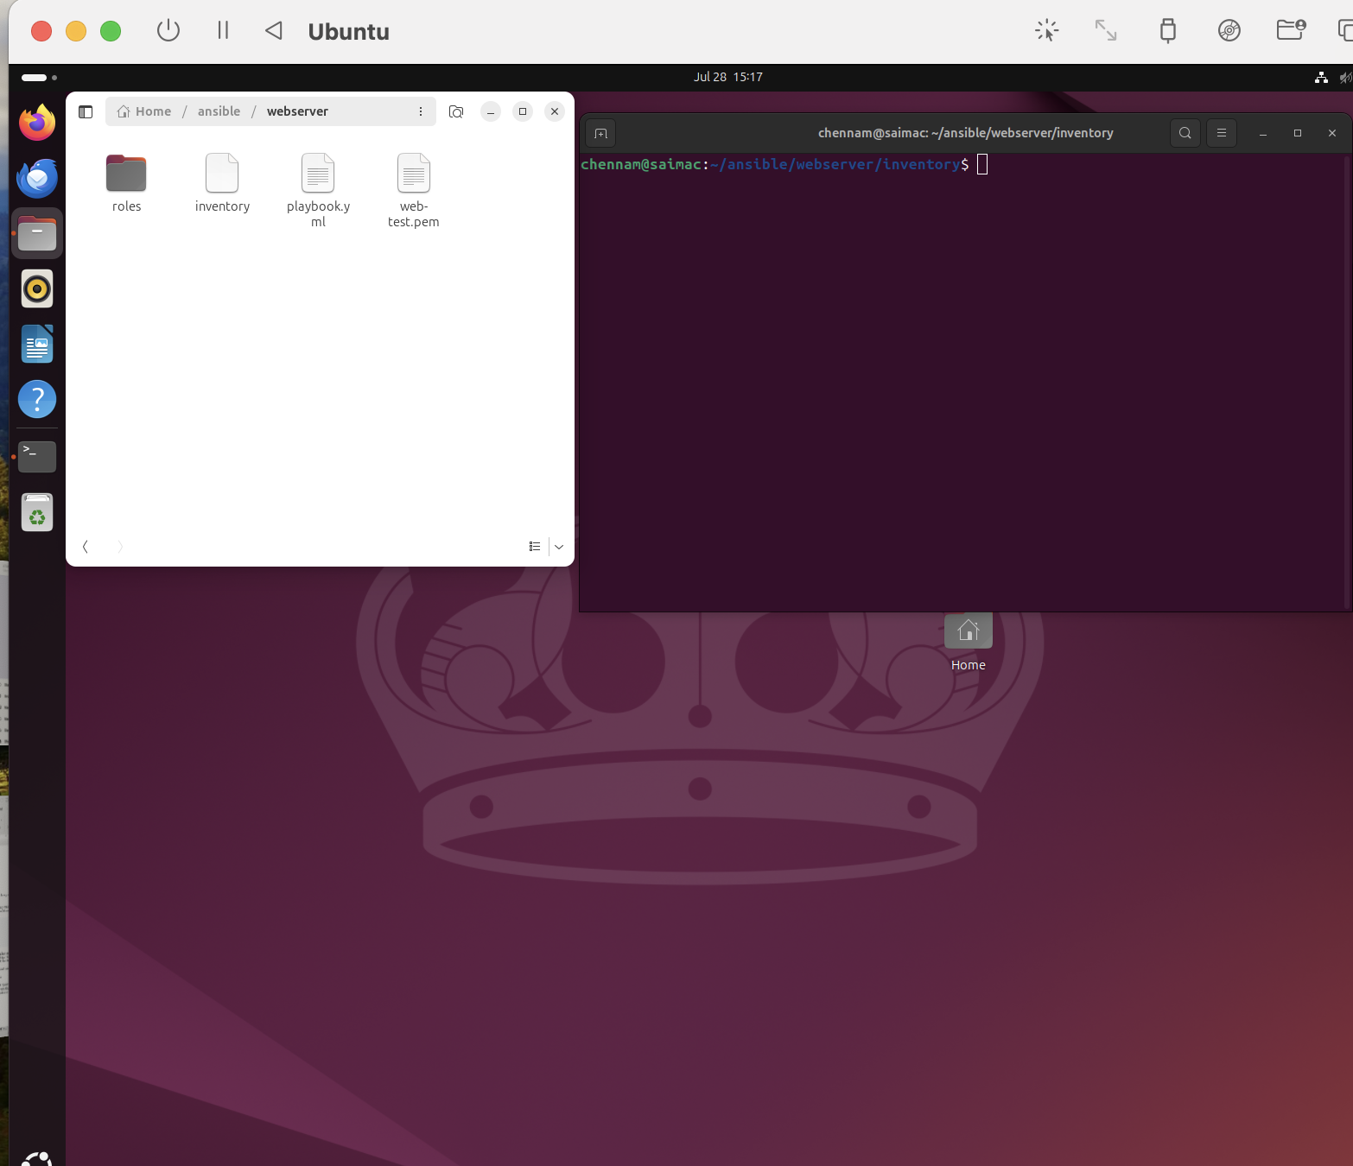

* Creation of Inventory file and run the playbook file in Ansible.

**Step – 5**

**Setting up the S3 Bucket and cloud Front**

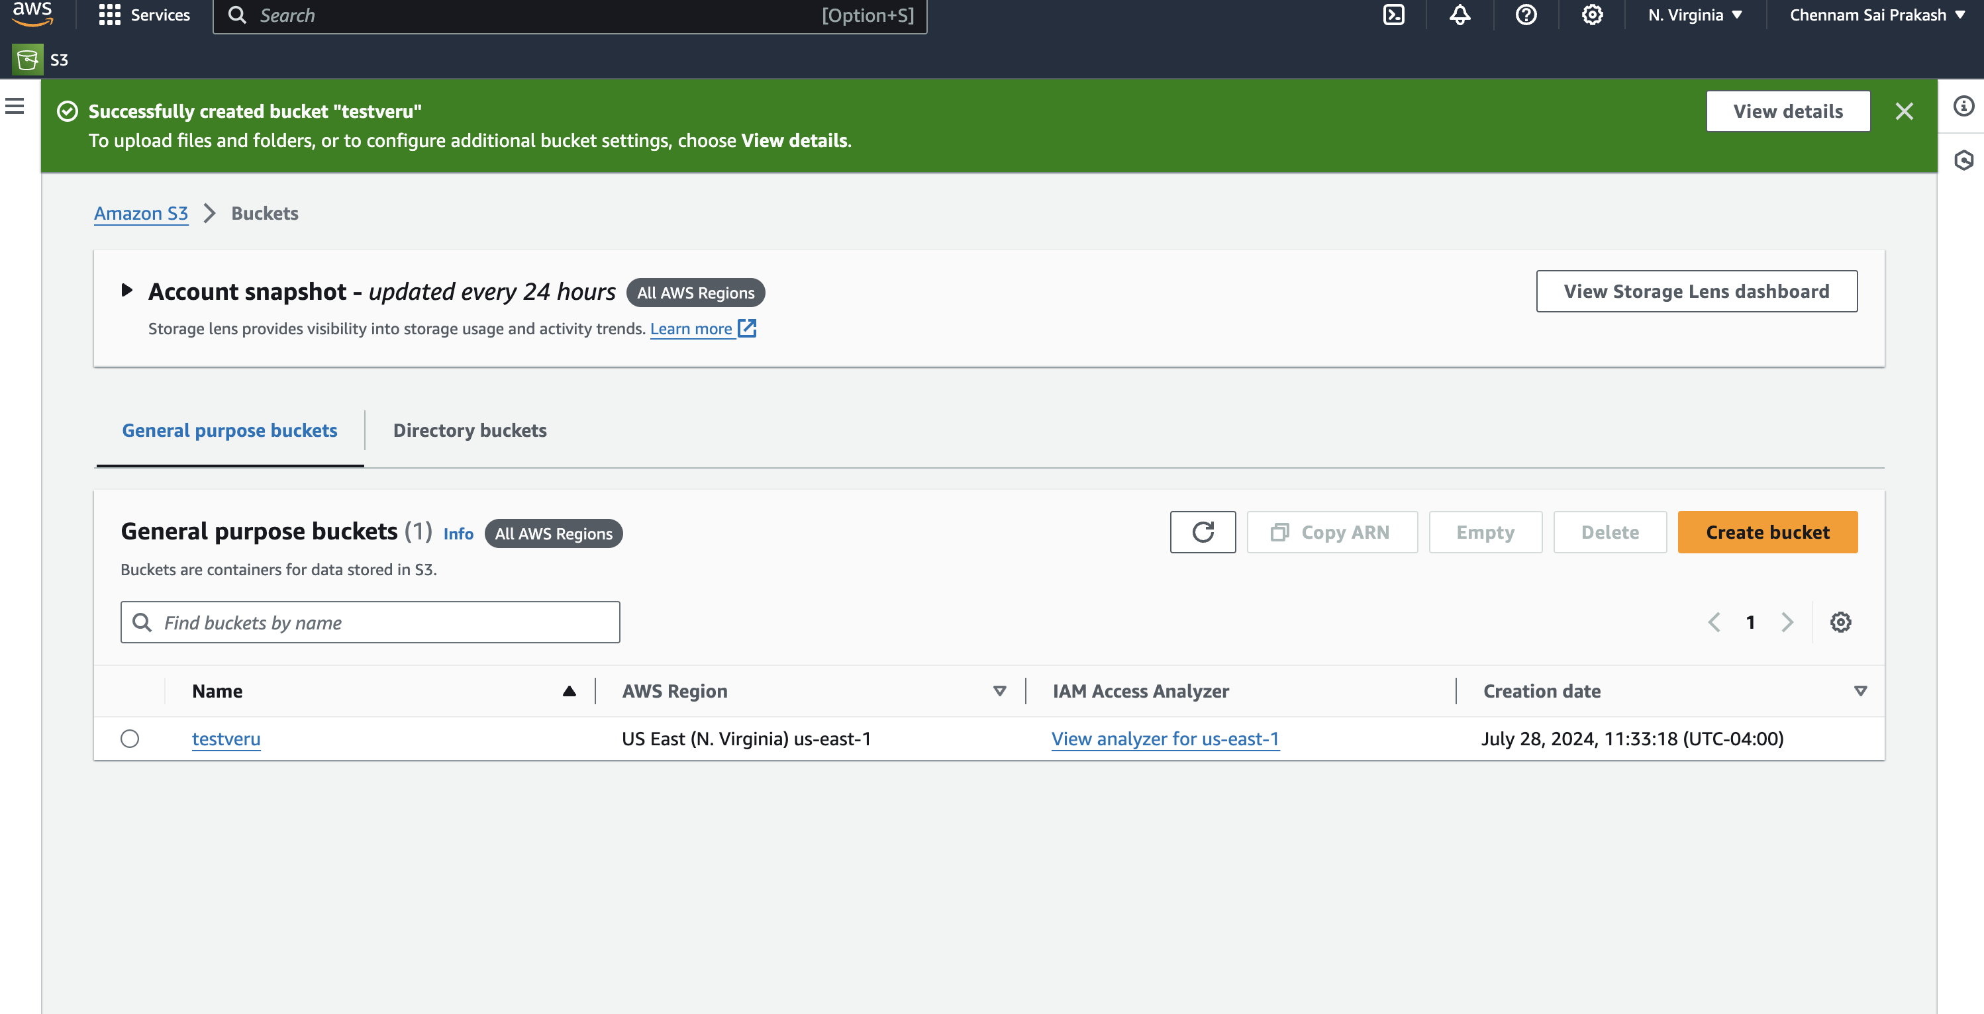

* **S3** bucket is created and will upload the index.html file into it.

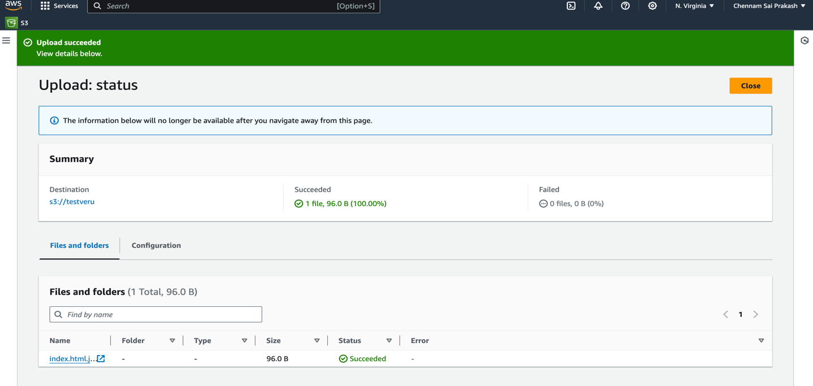

* The web application configuration file is uploaded into the S3 Bucket.

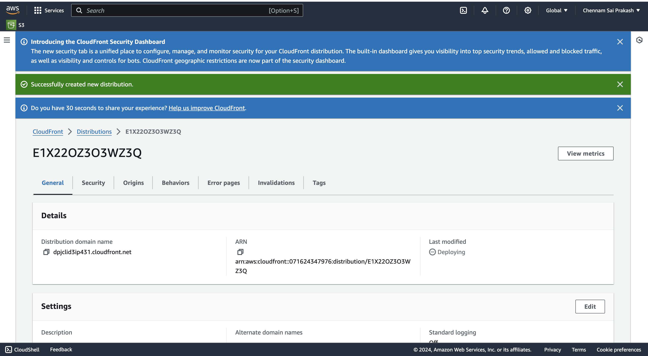

* In this step I had configured the cloud front security to use with S3 bucket as the origin.
* After setting up the AWS cloud front next is to setup the EC2 Instance.

**Step – 6**

**Deploying the Configuration.**

* As we had already setup the EC2 Instance for the Web Application, Now just go to the Instance and connect the Instance.

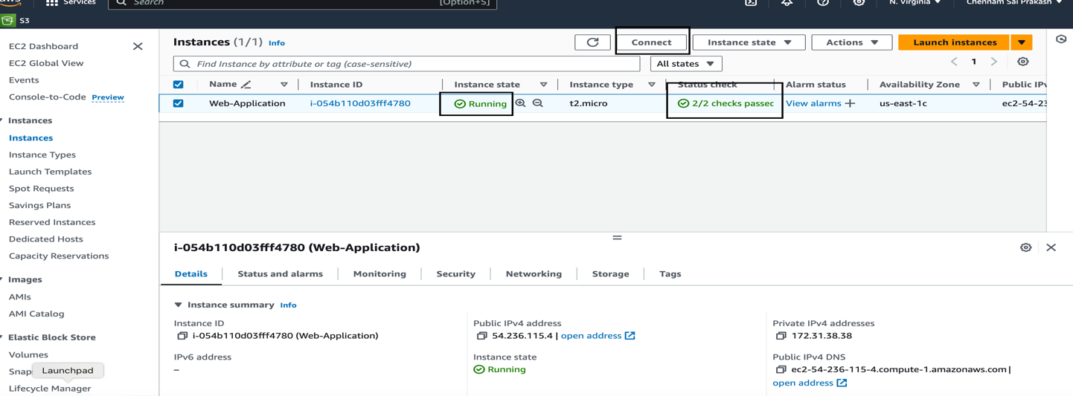

* After starting the Instance ensure that the Instance state is active, and it is running. Once the Instance is in the desired state. Now ensure it is pointing to Ansible Inventory.

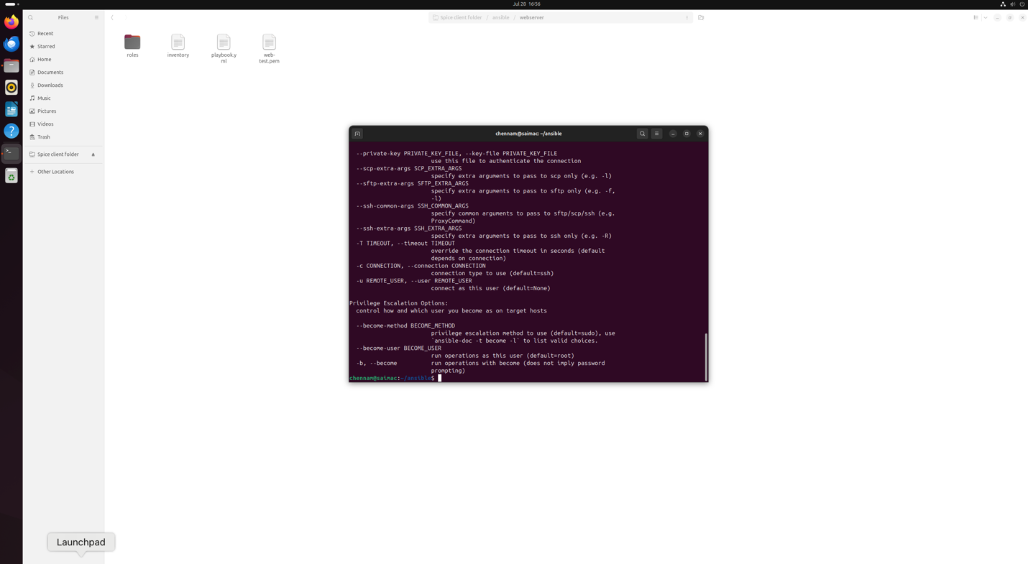

* As the EC2 is pointing to the Ansible Inventory now execute the playbook to configure the web server to the application.
* And above snapshot confirms that the playbook is executed and configured to the web server.

**Step - 7**

**Monitoring and Scaling**.

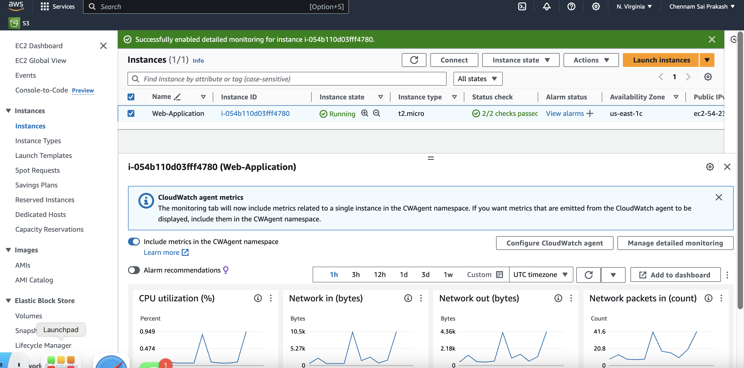

* I had Configured the EC2 Instance and setup the cloud watch for the Instance to monitor the CPU Usage and log metrics.

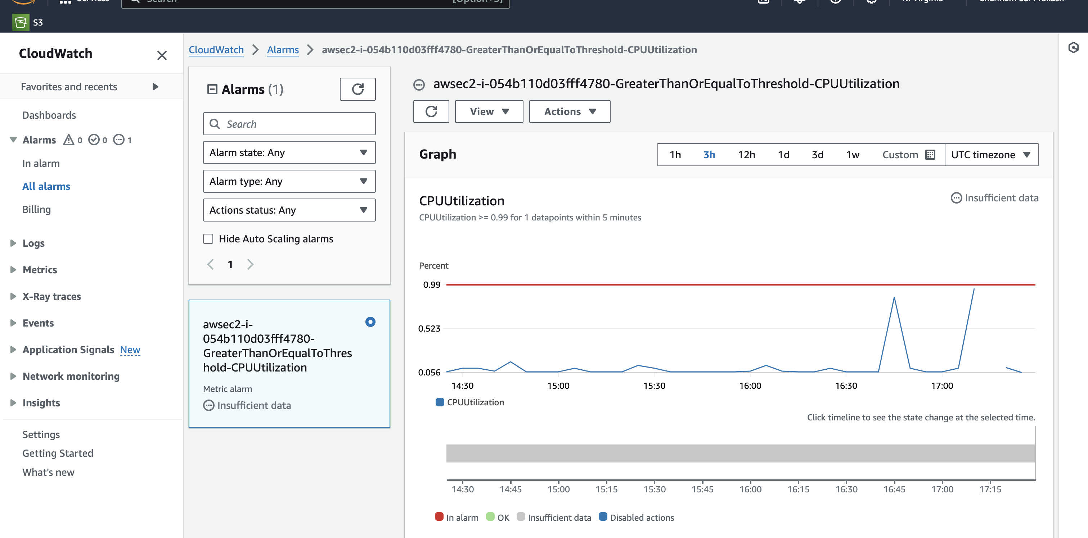

* I had setup the cloud watch Alarms for a parameter “**CPU Utilization**”. We can choose the required metrics of our choice. For an instance to get the data I had chosen CPU Usage.

**Challenge 2**

Coding Challenge:

**Code:**

import re

n = int(input())

for i in range(0,n):

x = input()

if(x.count("-")>0):

a = x.split("-")

p=1

if(len(a)!=4):

p=None

a=[]

for b in a:

if len(b)!=4:

p=None

break

else:

p=re.search("[456][0-9]{15}",x)

x=x.replace("-","")

q= re.search(".*([0-9])\\1{3}.*",x)

if(p!=None and q==None):

print("Valid")

else:

print("Invalid")

Output Screenshots of the coding challenge showing the test cases.:

